**Restaurant Management System**

# Abstract:

*In this project, we have built a restaurant management system. In which we have included a system for Management and Customers as well. For Management, they can add or delete items from the menu list, they can change the name of the item and their prices as well. They can also view the Feedbacks from the customers also they can check the orders. For customers, they can view the menu (can check what item the restaurant had and at what Price). They can select the items they want to order and in more than one quantity. They can also select the type of order they want like dine-in or take-away. Other than that the customers can share their feedback related to the restaurant. For the customer we have also build a reservation system (......later.......). We have also built a payment system for the customers. Where they can select the payment method like using of cards or payment by cash*.

## Main Functionality of Code:

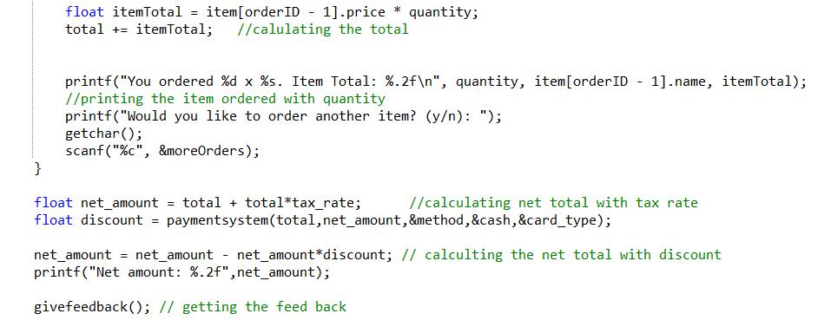

* *Have used* ***Float*** *(as the price of item can be in decimal so the* ***itemTotal*** *same for the* ***net_amount*** *and* ***discount*** *as well).*
* *Used* ***Scanf*** *to ask from the user.*
* *Using* ***Printf*** *for printing the Net amount.*
* *Used* ***getchar*** *for buffer handling.*
* ***Givefeedback()*** *is already explained. Used it to in a function to connect within* ***takeorder*** *function  
  attach Ss of this function and explain.*

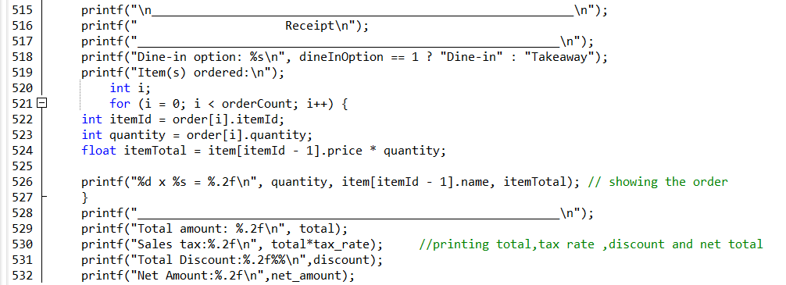

* *Printing the receipt of the order*

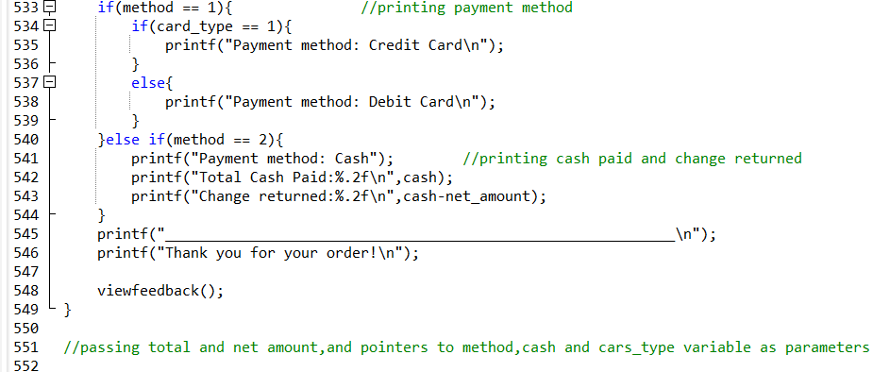

* *Using* ***If-else-if*** *for payment method.*
* *Used* ***nested if-else*** *in method 1 for further asking for card type. Credit or Debit.*

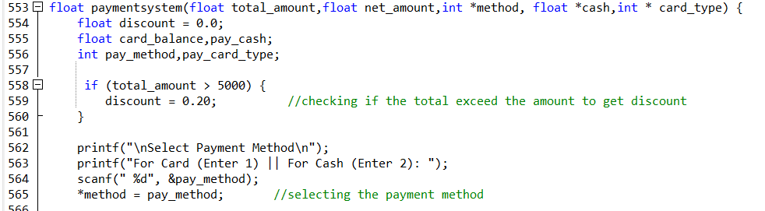

* *Using* ***pointers*** *to connect the* ***\*method,*cash,*card_type*** *from a different function. In my case I am connection* ***method,cash,card_type*** *from function* ***takeorder*** *to function* ***paymentsystem*** *so the total_amount can be connected with the other function.*

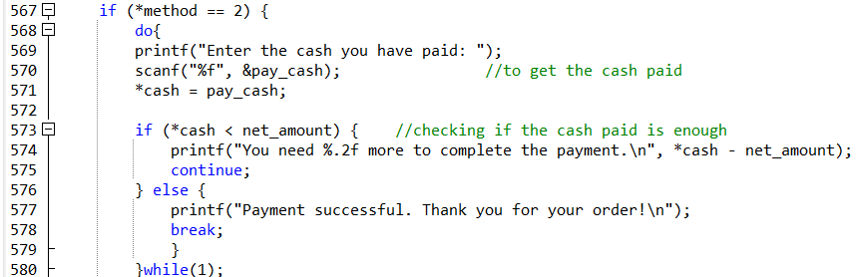

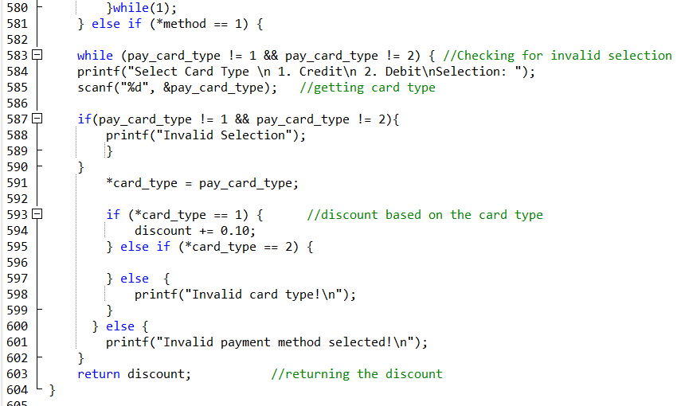

* *Using* ***nested if-else*** *with* ***pointer*** *to connect the order with the* ***cash system****. And giving discounts which will be applied to the order’s bill.*